User Guide for “Resources for COVID-19”
Updated on 3/20/20020
- Website：https://dataverse.harvard.edu/dataverse/2019ncov
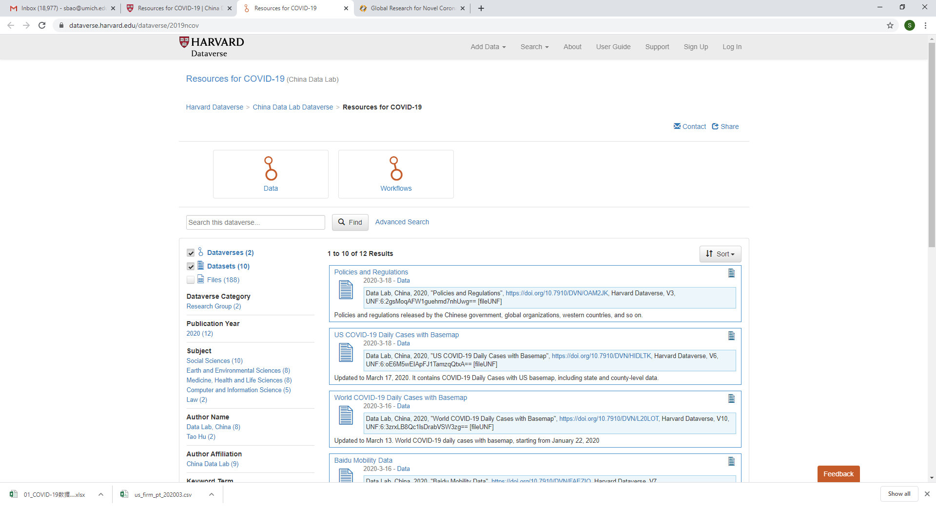

- Resources Structure
- Data (dataVerse)
  - Policies and Regulations (dataset)
  - US COVID-19 Daily Cases with Basemap (dataset)
  - World COVID-19 Daily Cases with Basemap (dataset)
  - Baidu Mobility Data (dataset)
  - China COVID-19 Daily Cases with Basemap (dataset)
  - Health Facilities (dataset)
  - GIS and Public Health (dataset)

- Workflows (dataVerse)
- COVID19 Stats Analysis (dataset)
- COVID19 Literature Analysis (dataset)

- Explore Data Online or Download data
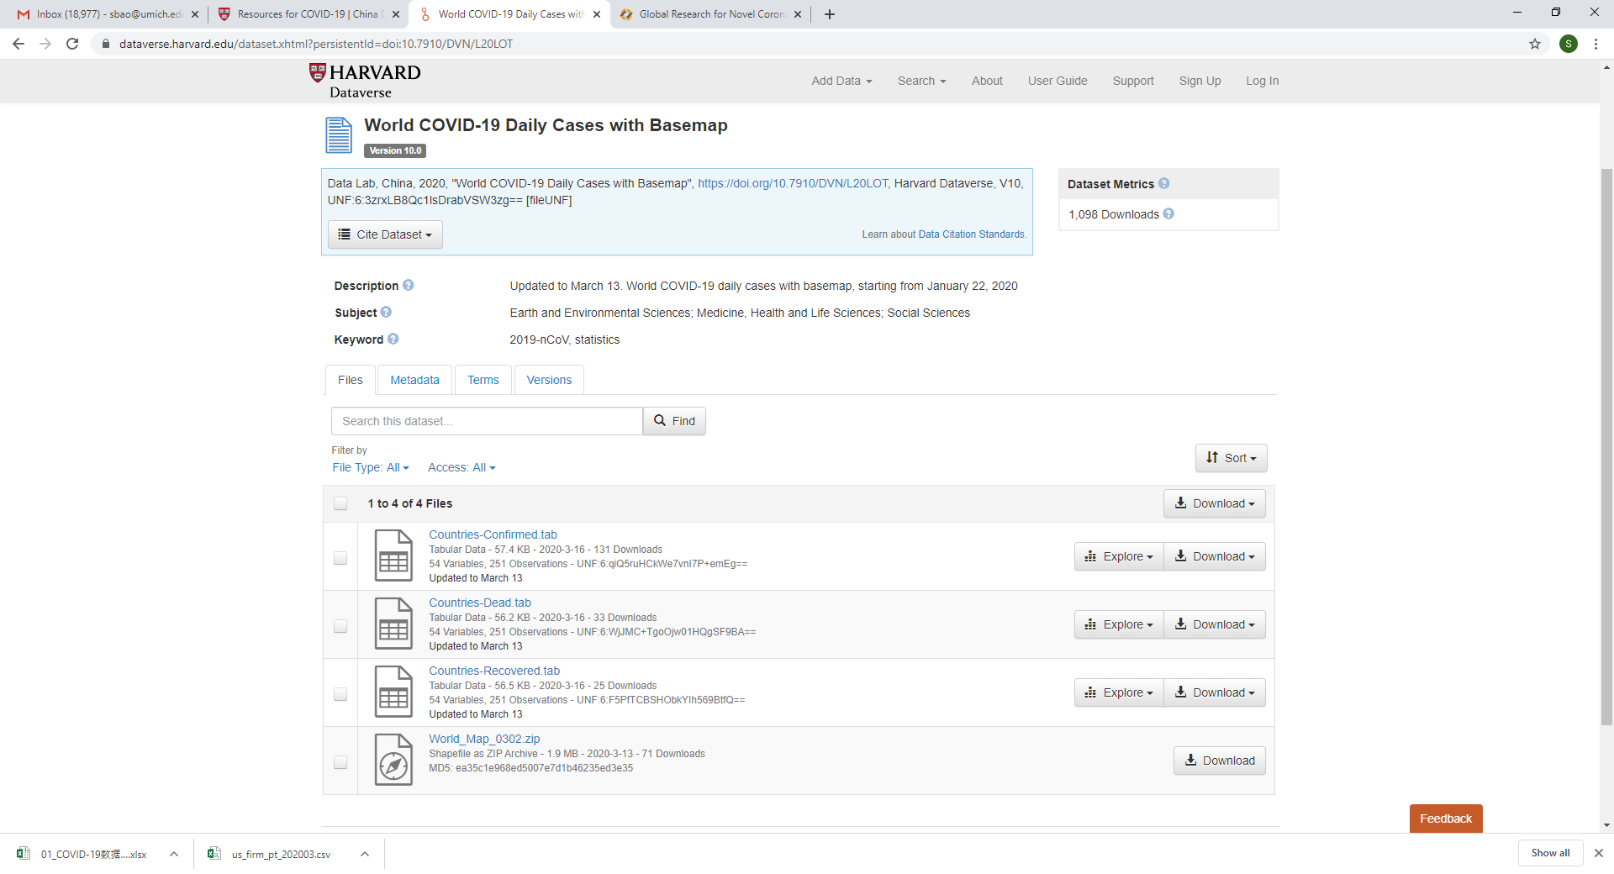
For data contributions, questions or suggestions, please contact:

Center for Geographical Analysis
Harvard University
Email: Spatialdatalab@lists.fas.harvard.edu
Web site: http://chinadatalab.net

